REPORT LINUX

NAMA : AIDI RAHIMI BIN SOHAIMI

IC NUMBER : 970718-06-5071

ID NUMBER : 3278

**Activivity 1**

1. How to open a terminal in Ubuntu.

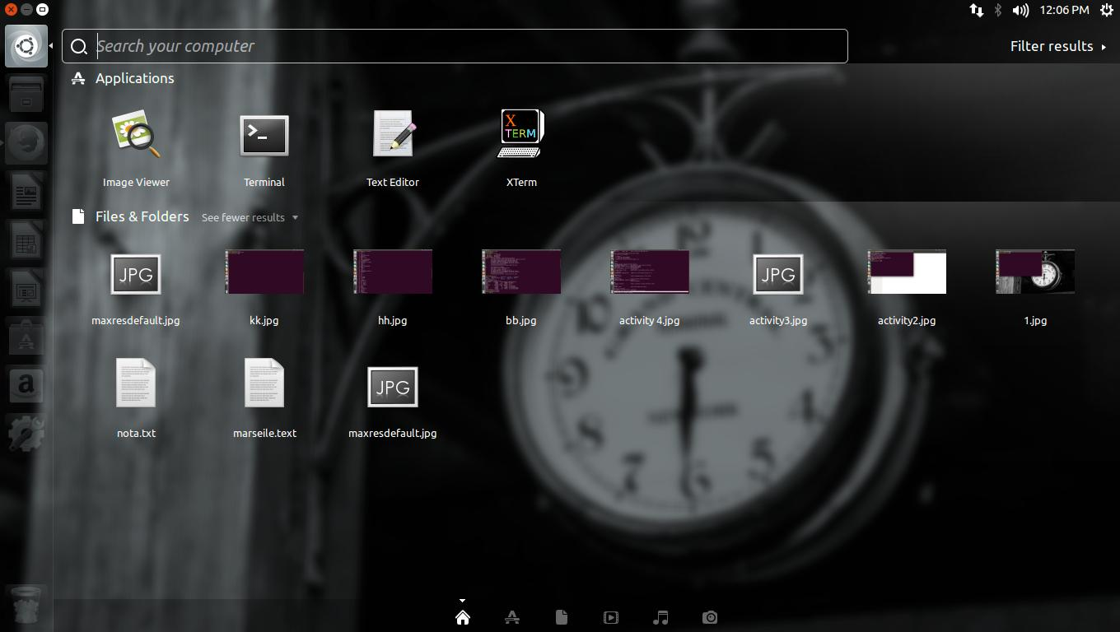

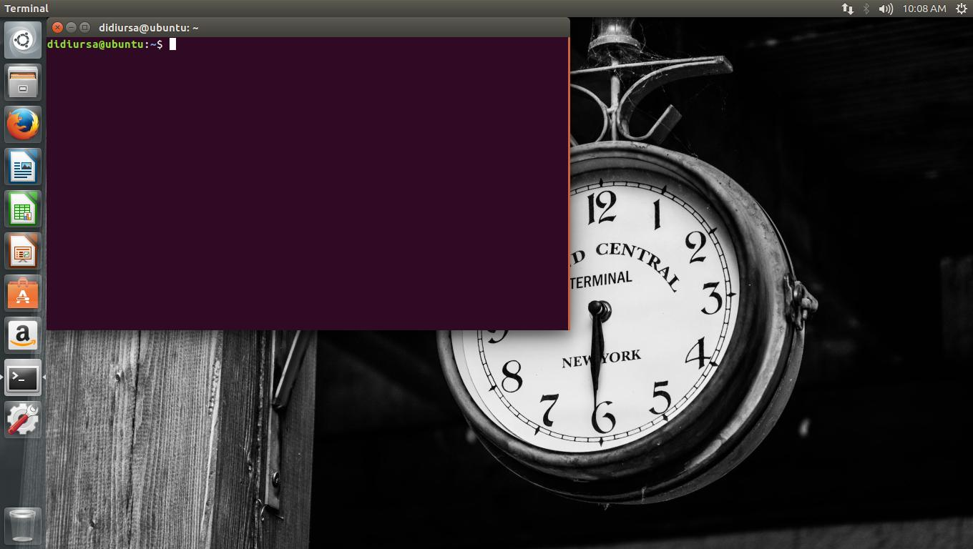

**Activivity 2**

* How to run the system as a root and change password.

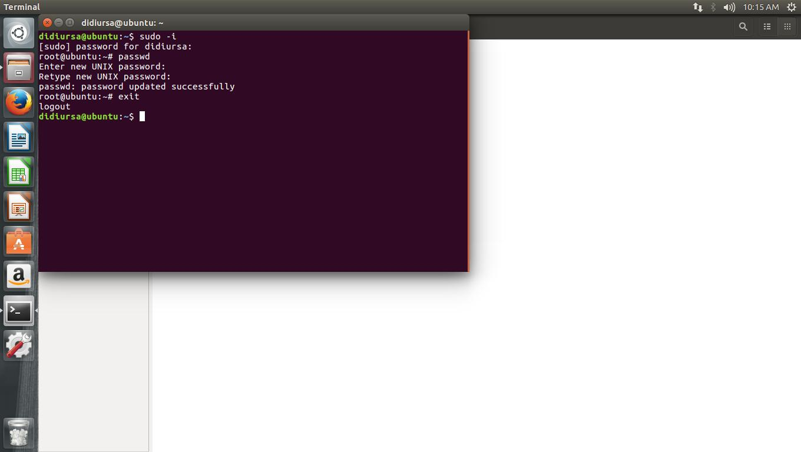

**Activity 3**

* How to explore Linux using simple commands.

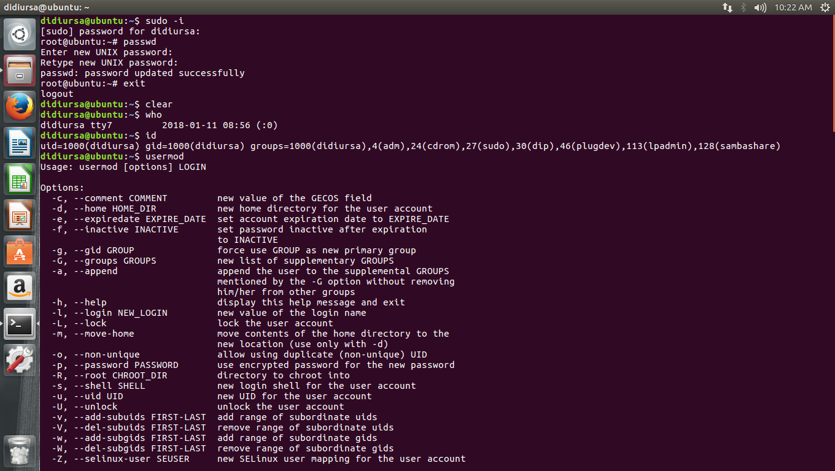

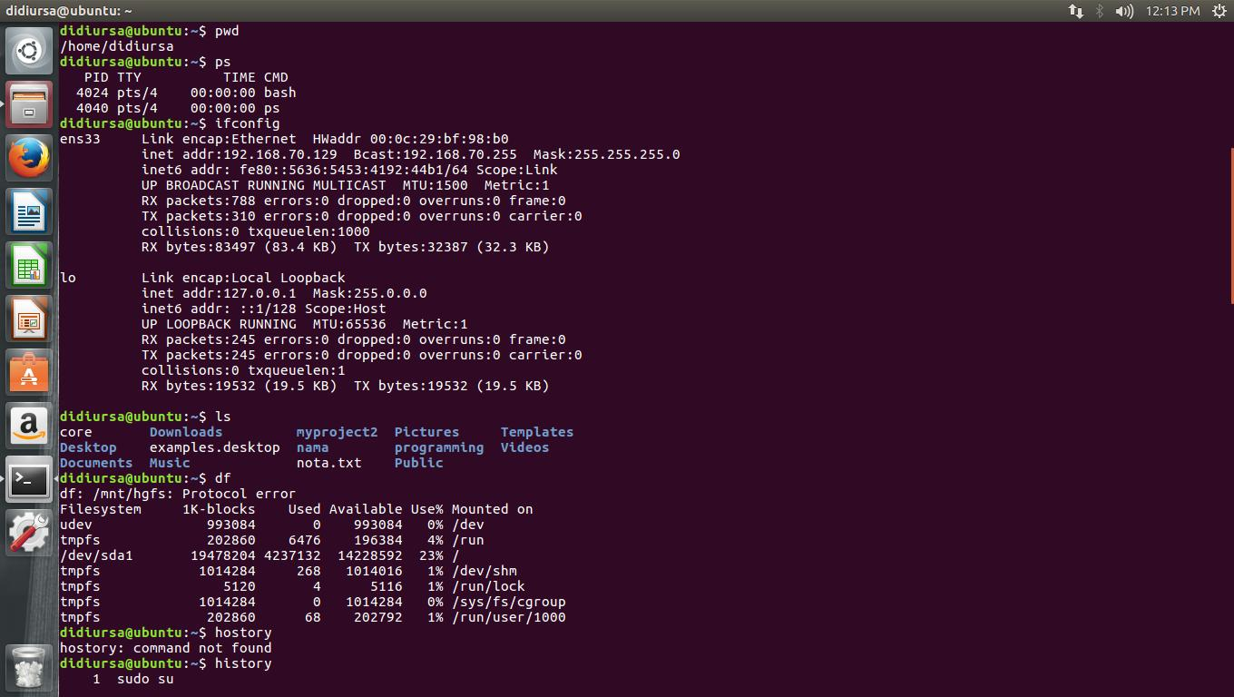

**Activity 4**

* How to use command as shown below

